HUNGARIAN VIZSLA SOCIETY
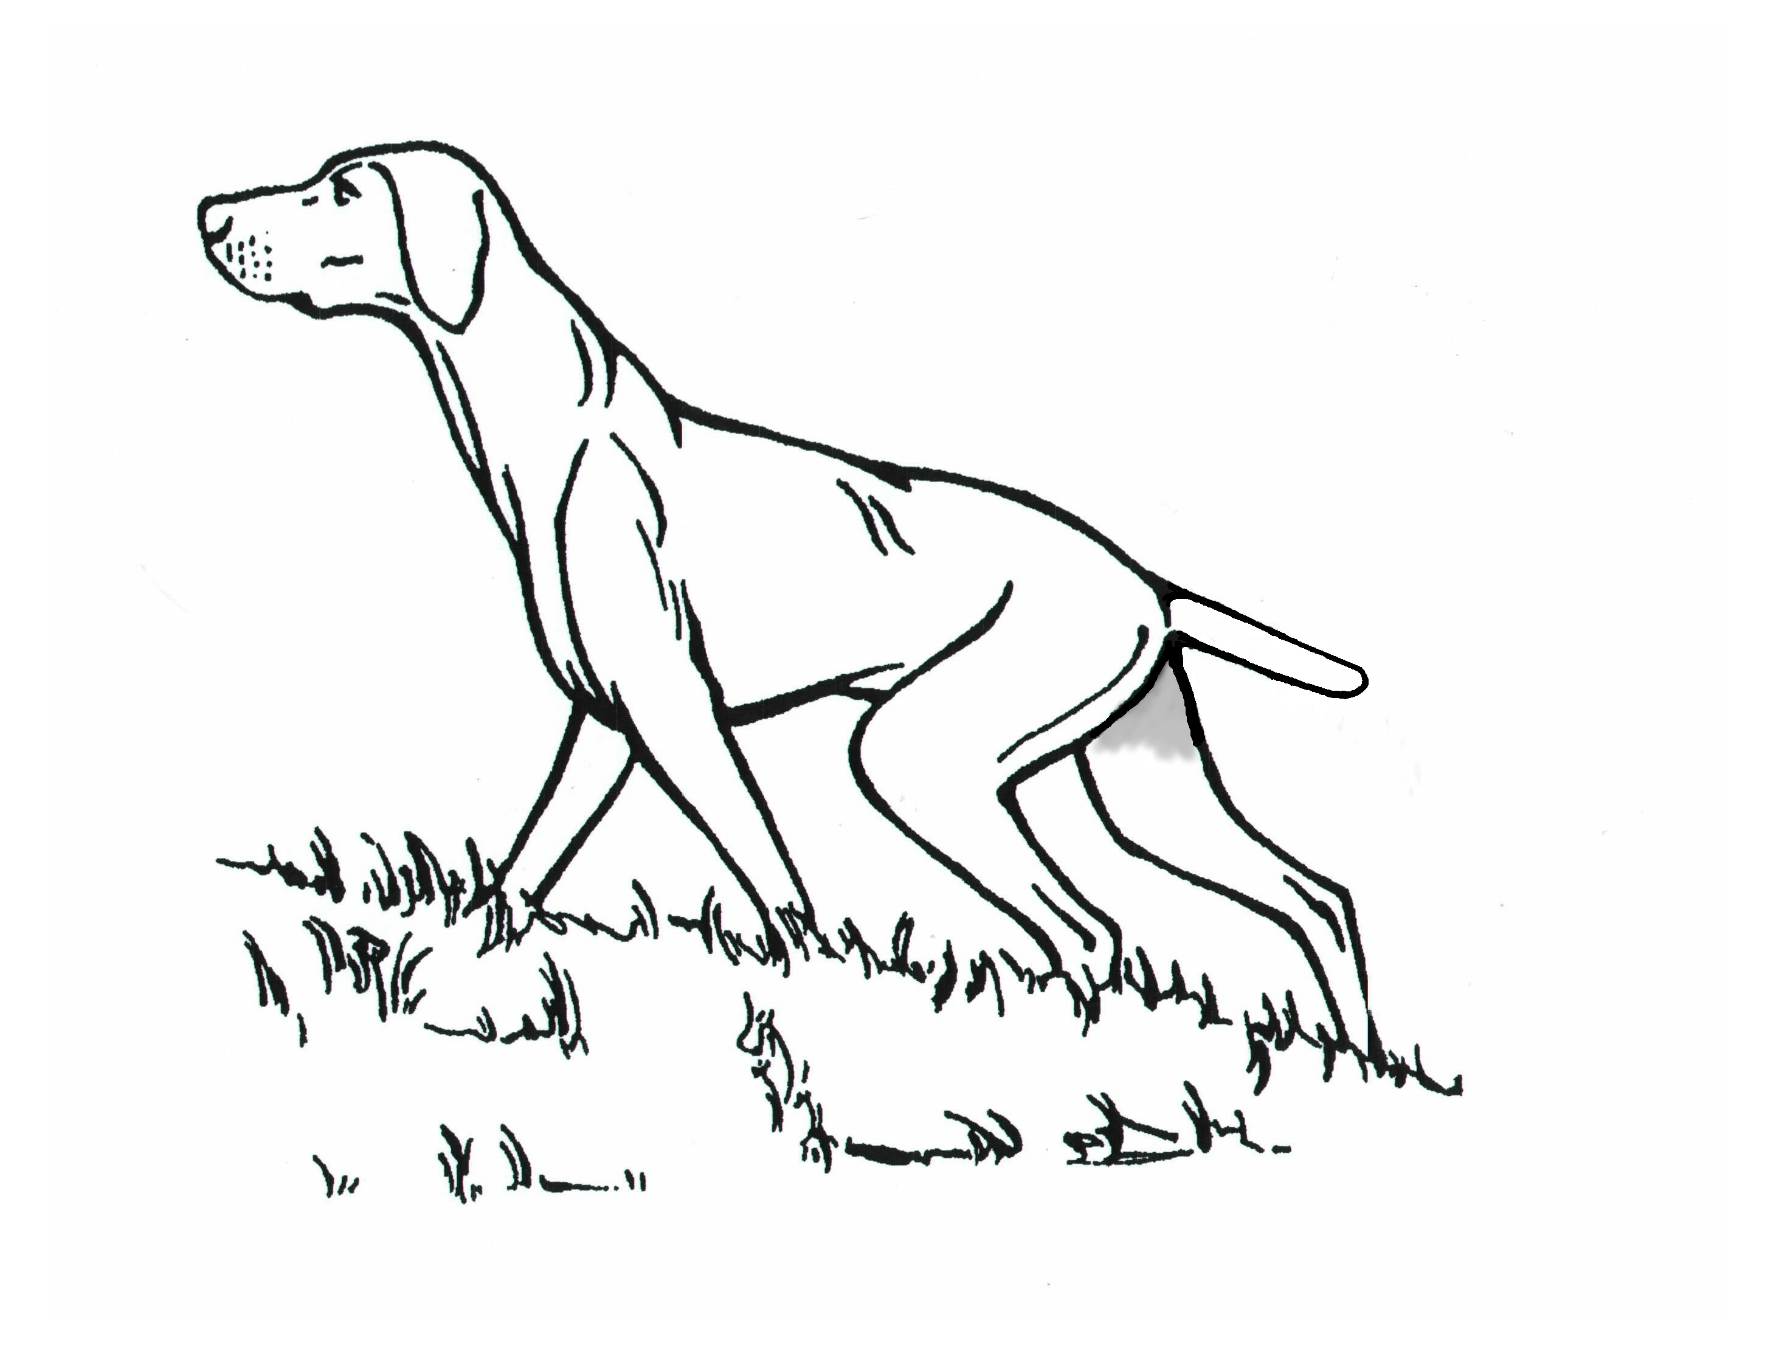

WORKING TEST
For all breeds which hunt, point & retrieve
Held under Kennel Club Rules

SUNDAY 27th May 2018
Grange Farm, Over Worton, Oxfordshire.
By Kind Permission of Mr Richard & Jenny Schuster

Start: 9am for a 9.30 prompt start. We hope to finish all tests by approximately 4 pm.
Stakes: PUPPY (Saddleglade Trophy) Judge:- Sara Barnard
Confined to dogs under the age of 18 months on the day of the test
NOVICE (Abbeystag Bruna Trophy) Judge:-Lloyd Birch, Peter Szalai, Bradley Dymond
Confined to dogs which have not gained an award or Certificate of Merit at a field trial, or a First, Second or Third in an open Gundog Working Test or a First in a Novice Gundog Working Test held in accordance with Kennel Club Regulations.
OPEN (Istvan Tizen Kilenc Memorial Trophy) Judge:- Mr Ray Davis
Open to dogs of Open standard, able to hunt and retrieve fur or feather over land and over water.
WATER To judge all classes Judge:- Sue Harris
Additional judges may be brought in should the entry necessitate

New Trophy this year: 'Vizellven Young Achiever Award'. Awarded to the highest scoring puppy less than 12 months of age on the day of the test.
CONFORMATION MAY BE HELD
OUR WORKING TEST IS KINDLY SPONSORED BY

SKINNERS DOG FOODS
Entry Fees:- £12.00 per dog to Hungarian Vizsla Society Members. Non Members £15.00. Please make cheques payable to the Hungarian Vizsla Society. The Drawer will meet the costs and charges of returned cheques.
Entries Close:- 20th May 2018. Please get your entries in on time as no late entries will be accepted.
DIRECTIONS: Nearest Sat Nav is OX7 7ES
THIS IS THE ACTUAL HOUSE, DO NOT GO THERE BUT FOLLOW SIGNS TO PARKING. Signs will be out on all approach roads,
please follow as they will take you to the parking near farm. Head for Middle Barton from there turn left on Worton
Road then follow this road to the T junction (approx. 2to 3 miles) then turn left, after ¼ mile look for Grange Farm
signs on the right .

Raffle: There will be a raffle on the day. Any unwanted old Christmas presents from long lost Aunts or donations will be gratefully received.

Please bring 2 canvas dummies with you on the day. Open tests may include cold game.
LIMITATIONS. The Hungarian Vizsla Society, welcomes your valued entry, however so that spectators and competitors can enjoy the day, may we ask you for your kind assistance in observing the following guidelines. Please do not bring bitches in season onto the working test area. Please keep all dogs on a lead, unless under Judges Orders, or under Handlers control in an exercise area. Please do not carry out punitive correction of a dog! This would be inappropriate response, and one the Hungarian Vizsla Society cannot support. It will invariably lead to disqualification and spoil everyone’s day

CONTACT NAME: FT Sec, Mr Mark Jones, Roughy Farm Bungalow, Lower Upham Hants SO32 1JP Tel 01962 777451
Email: mark_jones75@sky.com

Emergency only contact details: Mark Jones 07801650000

