HUNGARIAN VIZSLA SOCIETY  WORKING TEST ENTRY FORM |  |  |  |  | VENUE  DATE |  | Over Worton, Oxfordshire  Sunday 27th May 2018 ID No. 1341 |  |  | ENTRIES CLOSE:  20/05/18  NO LATE ENTRIES PLEASE
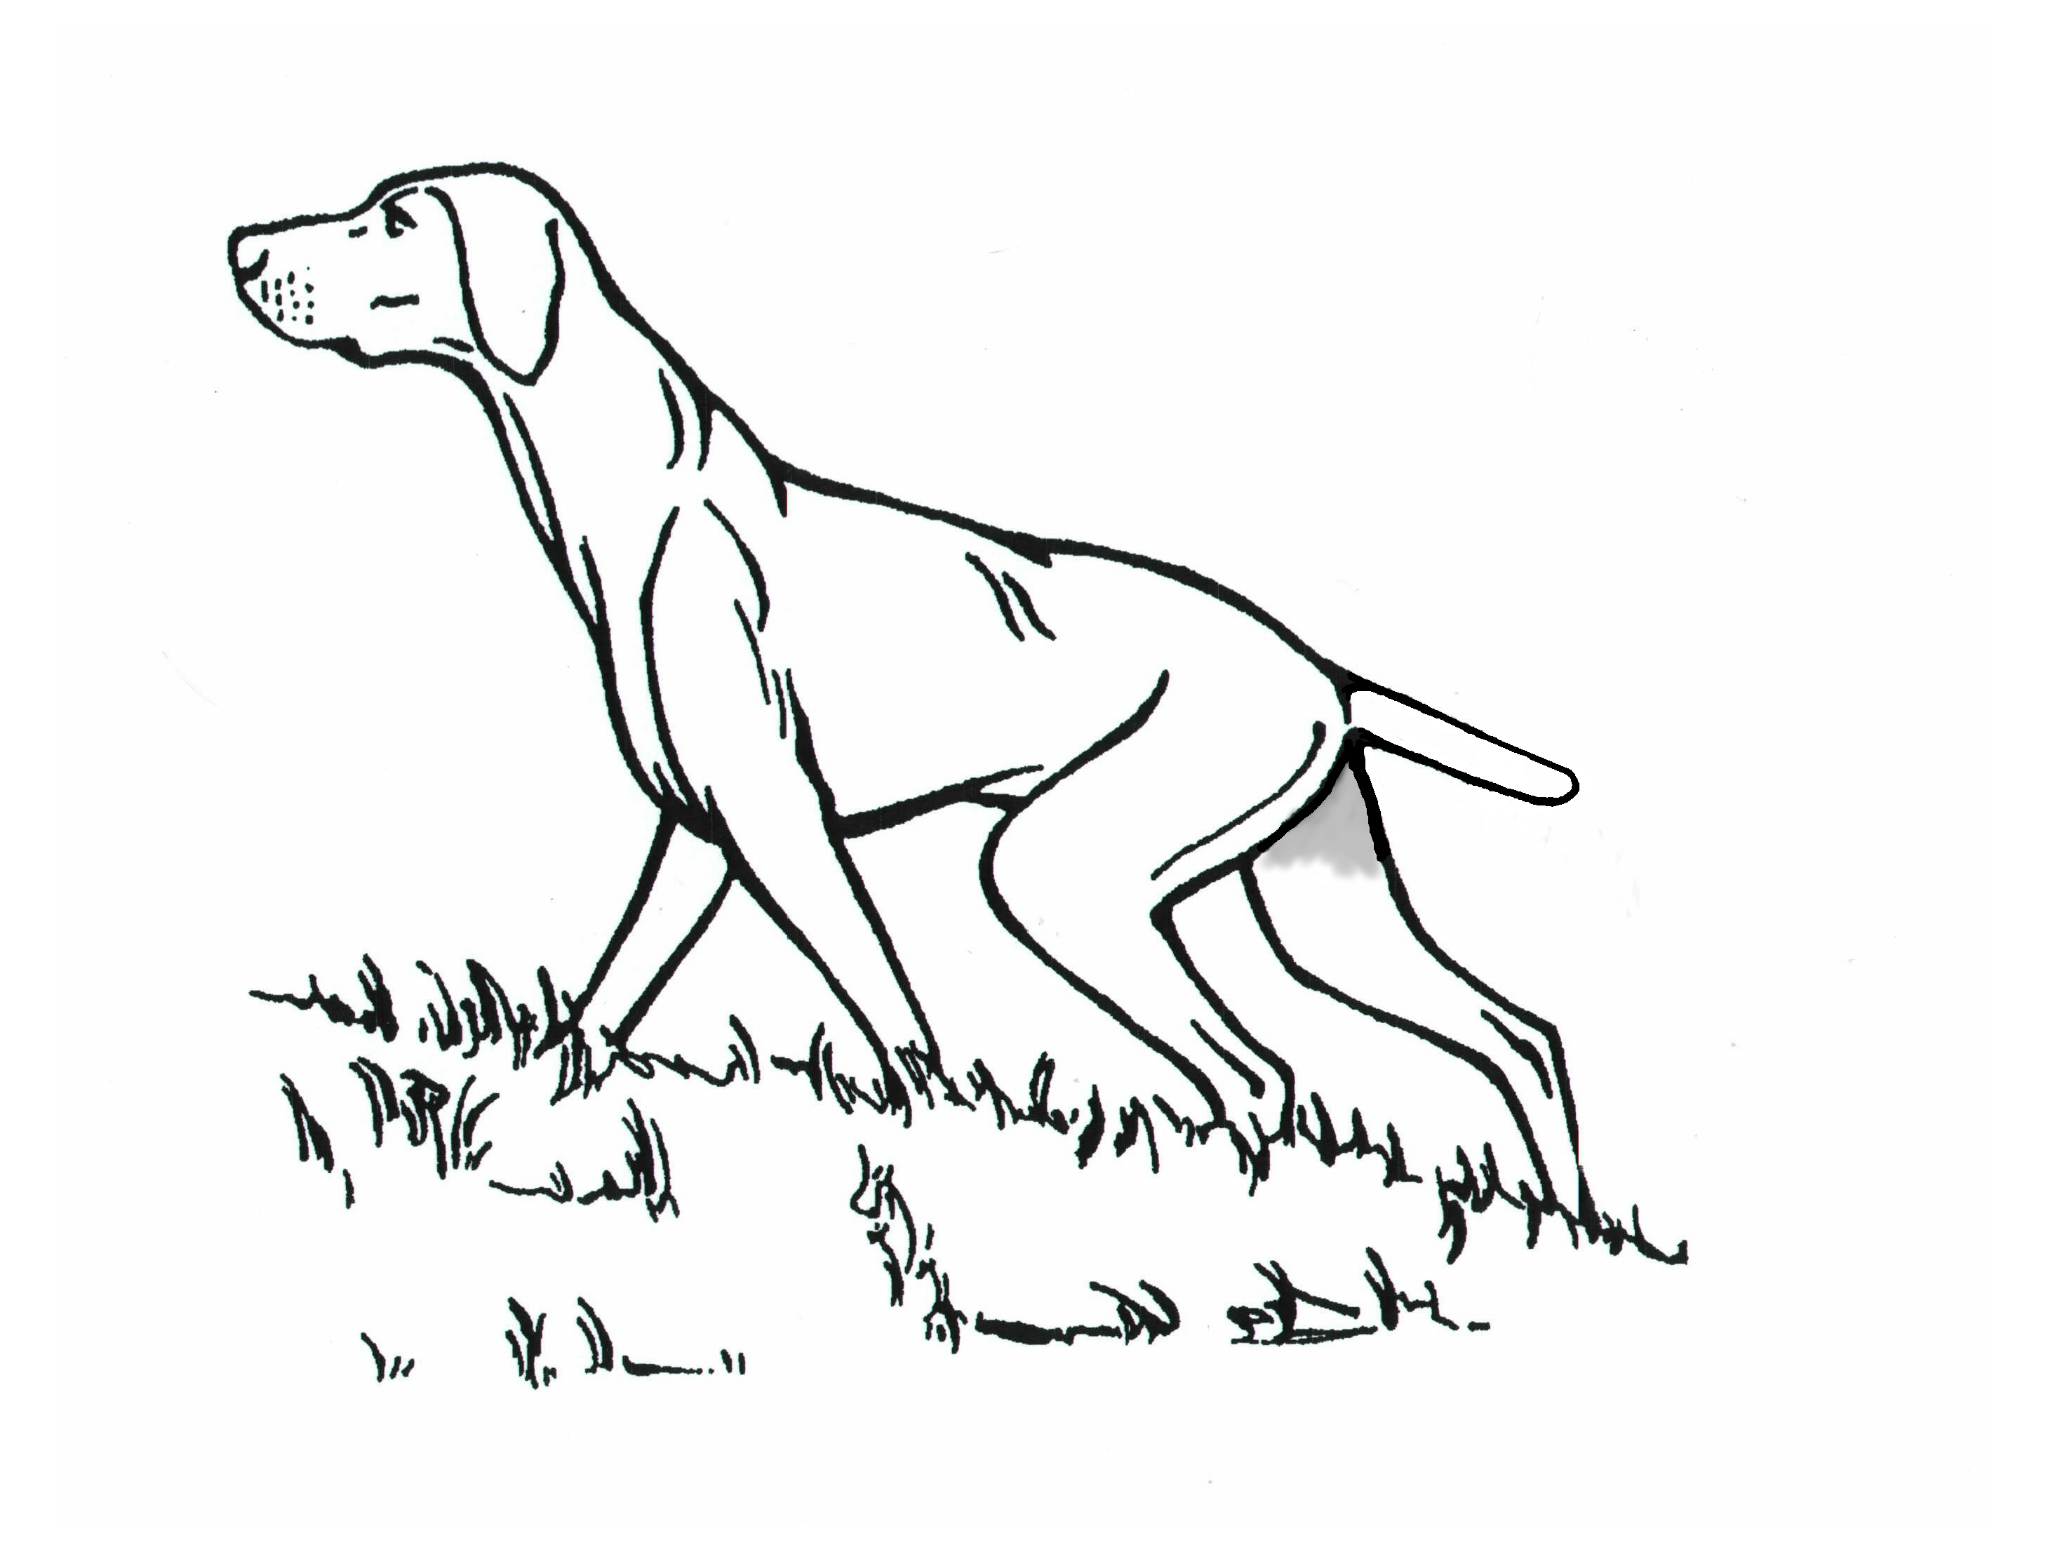 |  | INSTRUCTIONS: Writing MUST BE IN INK AND BLOCK CAPITALS  This form must be used by one person only (or partnership).  Use one line only for each dog. The name of the dog and all the details as recorded with The Kennel Club must be given on this entry form. If an error is made the dog may be disqualified by the Committee of The Kennel Club. ENTRIES FOR FIELD TRIALS WILL ONLY BE ACCEPTED FROM GUNDOGS REGISTERED AT THE KENNEL CLUB IN THE GUNDOG GROUP (vide Reg. J1.a., 6a(i) & B20) and if a registered dog has changed ownership the TRANSFER must be applied for before the closing of entries.When entering more than one breed or variety, use if possible a separate form for each. On no account will entries be accepted without fees. |  |  |  |  |  |  |  | Entry Fee: Payable to HVS  Members; £12.00  Non-members; £15.00.  Vizsla Rescue Donation £1.00 (Discretionary)
 | REGISTERED NAME OF DOG  (BLOCK CAPITALS) |  | KENNEL CLUB  REG NO., STUD  BOOK NO. OR  ATC NO. |  | FULL DATE  OF BIRTH | BREEDER |  | SIRE  (BLOCK LETTERS) | DAM  (BLOCK LETTERS)
1 |  |  | BREED |  | SEX
2 |  |  | BREED |  | SEX
 |  |  | Puppy | Novice | Open | Name of Owner (s) (In block letters)
1 | CLASS (PLEASE WRITE) |  |  |  |  | ADDRESS
2 | CLASS (PLEASE WRITE) |  |  |  |  | Telephone No Fax No
ONE LINE FOR EACH DOG CHECK ALL DETAILS BEFORE POSTING  DECLARATION  “I/we agreed to submit to and be bound by The Kennel Club Rules and Regulations in their present form or as they may be amended from time to time in relation to all canine matters with which The Kennel Club is concerned.  I/we also undertake to abide by the Regulations of this Trial and not to bring to the Trial any dog which has contracted or been knowingly exposed to any infectious disease during the 21 days prior to the day of the Trial. I also declare that I am fully conversant with the Field Trial Regulations and have studied the Guide to the Conduct of Field Trials.  I further declare that, I believe to the best of my knowledge that the dogs are not liable to disqualification under Kennel Club Field Trial Regulations.”  Usual Signature of Owner(s)…………………………………………….. Date ………………………………………….  Note: Dogs entered in breach of Kennel Club Rules and F.T. Regulations are liable to disqualification whether or not the owner was aware of the breach. |  |  |  |  |  | Entries and Fees which MUST BE PREPAID to be sent to: FT Sec, Mr Mark Jones, Roughy Farm Bungalow, Lower Upham, Hants. SO32 1JP  Phone: 01962 777451 E-mail: mark_jones75@sky.com  _____________________________________________________________________  Name Of Handler (In block letters)  ADDRESS  Telephone No Fax /Mobile No.  Email:-

