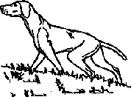 | Hungarian Vizsla Society Awards Claim Form
Dogs Registered Name: ………………………………………………

Owner: ………………………………………………
Please return this form before 15th February to:

Trohpy Steward, Sylvia Cox, Poplar Farm, Wood Nook, Grantham, Lincs, NG33 5AE
Event | Date | Place or Grade & Class | Points Claimed
Total points claimed

