German Longhaired Pointer Club

Results of the GLPC working test.
Held 11th July 2021 at Ducklington.

Puppy -
1st S Mills with Nemzet Kincse Gloria.
2nd - R Dockwray with Canalgame Jozef.
3rd - K Parrisnwith Bonario Galate.
4th - D Forsyth with Questor Ottilia
David also recieved the highest placed award for a GLP.
Novice.
1st - J Wall with Piroseg Mandarin of Perllanside jw
2nd - C Guest with Barantop Banoffee.
3rd - M Roger's with Disglairhill Apache.
4th - S Mattravers with Huntstone Arya.
COM - S Zarpanely with Kewpond Buttons & Bows.
Highest placed GLP - S Connor with Wamilanghaar Rudi.
Open.
1st - Emma Carter with Pioroz Cuddownego Lasu (imp Pol).
2nd - L Holmes with Ladyhawke Perdita.
3rd A Farley with Warrendown Genesis.
4th - S Mills with Karrouki Windfire jw.
Com - S Mattravers with Huntstone Rhea
Highest placed GLP - S Connor with Questor Lutz.
The committee would like to thank our host Mr John Smith for allowing the club to run the day. To Mark and Liegh for thier help, advice and tolerance throughout the day.
All our judges, chief steward and stewards, dummy throwers, who came from far and wide to make this a successful event.
Our thanks also to Our new Sponsor
Working HPR's
I am bound to have forgotten something or someone, I hope not though.
I do have to say a special thanks to Theo ( Breed Health coordinator for our club) for taking the DNA samples from 12 longhairs this is to be contributed to the research that is being done in the Netherlands on Thyroid Cancer. Kathy our Secretary has been working closely with the people in the Netherlands to bring this about. It was a time consuming job, lots of documentation etc.

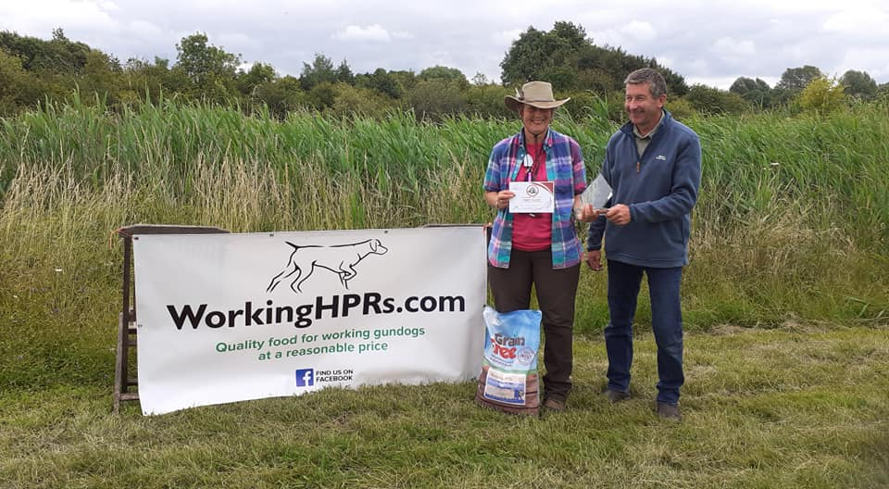

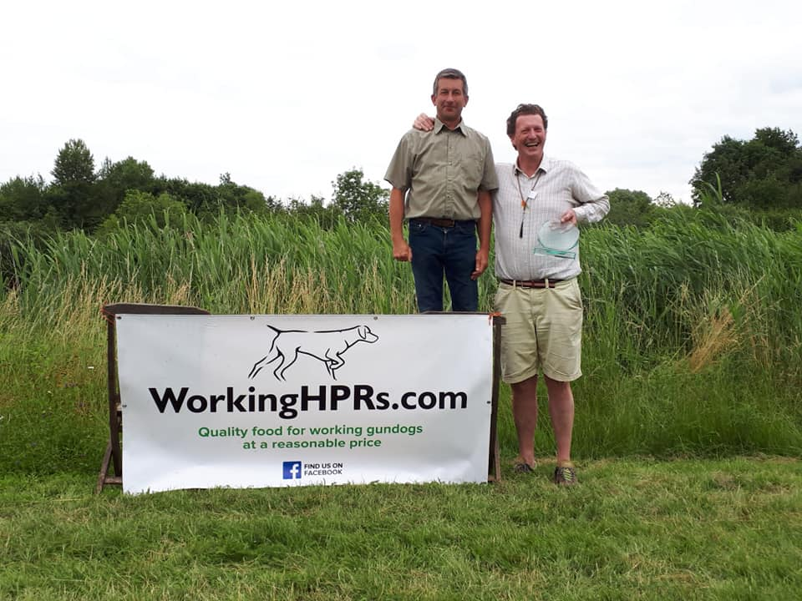

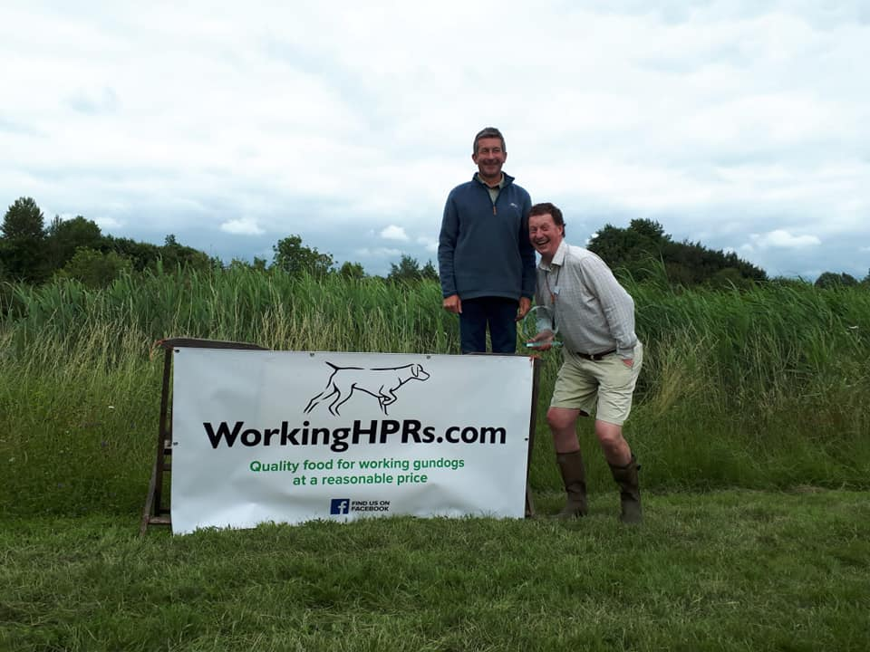

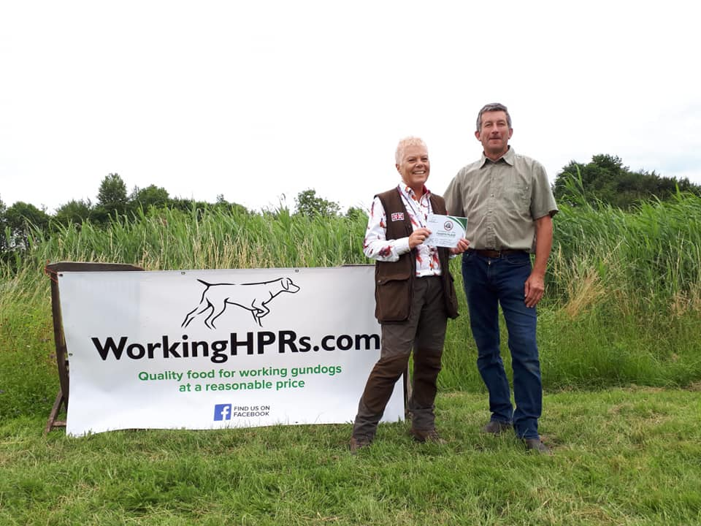
+5

