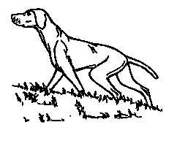
Hungarian Vizsla Society
ID NO. 1341
Field Trial Schedule

Hon FT Sec Mark B Jones, Roughay Farm Bungalow, Lower Upham Hants SO321jp mark_jones75@sky.com

Stake: Novice
Venue: Sherbourne st John nr Basingstoke
Directions: full directions will be given with the running order
By Kind Permission of: James and Lucy Bromhead
Date: 31-1-18
Time: 09:00
Judges: Jennifer Hurley 2598 Stephen Robson 2879
Entry Process: By Fosse Data or entries with payment sent to the FT Sec
Entries close: 16-12-17
Draw to be held on: 15-12-17

For Standing Instructions download from www.vizsla.org.uk or apply to Field Trial Secretary, Please note recent changes to the KC J Regs.

